SQL Clauses
1. Distinct Values:
⦿ a query to retrieve distinct salaries from the Employees table.
SELECT DISTINCT (salary) from employees;

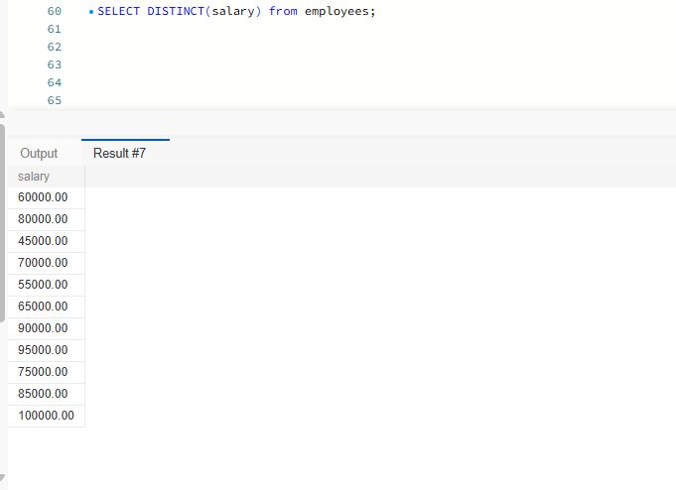
2. Alias (AS):
⦿ Provide aliases for the "age" and "salary" columns as "Employee_Age" and "Employee_Salary", respectively.
SELECT age AS Employee_Age, salary as Employee_Salary FROM employees;
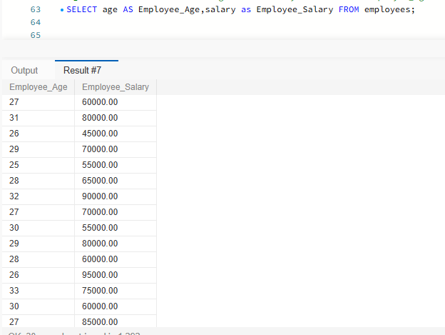
3. Where Clause & Operators:
⦿Retrieve employees with a salary greater than₹50000and hired before2016-01-01.
SELECT * FROM employees WHERE salary>50000 AND hire_date <'2016-01-01';
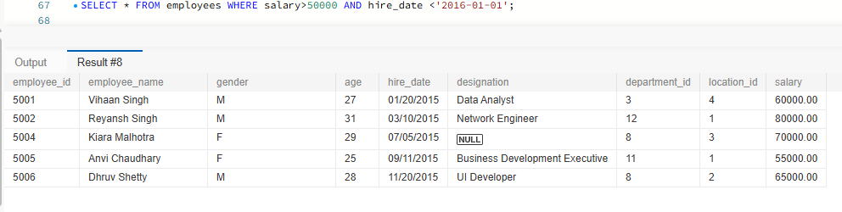
⦿ Find the employee whose designation is missing and fill it with "Data Scientist".
SELECT * FROM employees WHERE designation IS NULL;
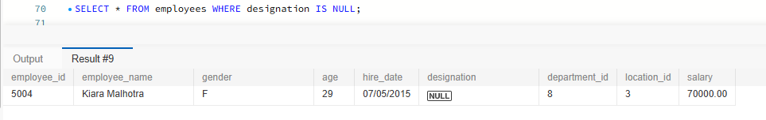
SELECT employee_id, employee_name, ifnull (designation,'Data Scientist') as Emp_Designation FROM employees;
(OR)
SELECT employee_id, employee_name, coalesce (designation,'Data Scientist') as Emp_Designation FROM employees;
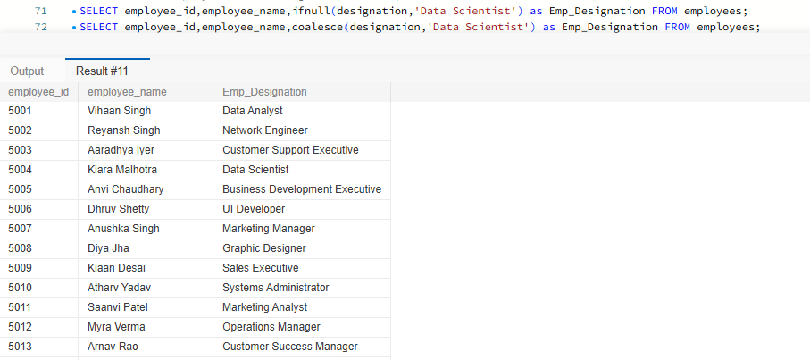
Sorting and Grouping Data:
1. ORDER BY:
⦿ Find employees sorted by department ID in ascending order and salary in descending order.
SELECT * from employees ORDER BY department_id ASC, salary DESC;
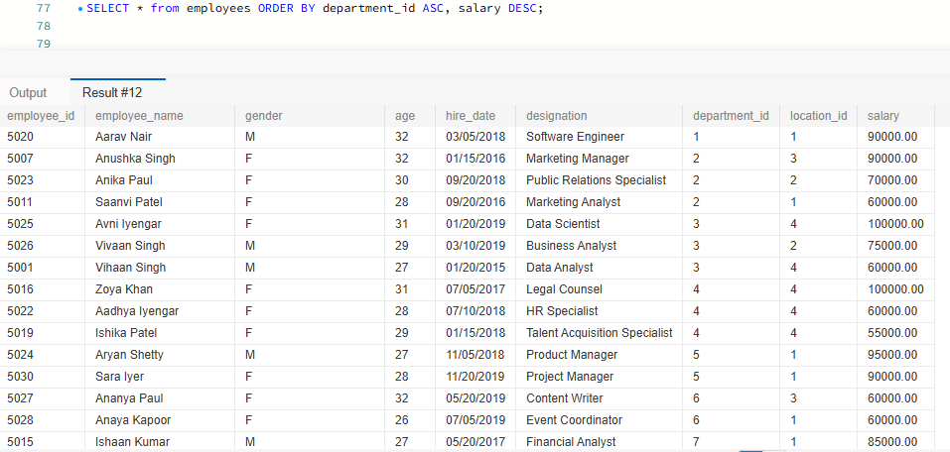
2. LIMIT:
⦿ Display the first 5 employees hired in the year 2018.
SELECT * FROM Employees
WHERE hire_date >= '2018-01-01' AND hire_date <= '2018-12-31'
ORDER BY hire_date ASC LIMIT 5; 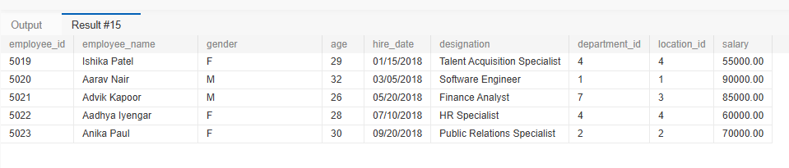3. Aggregate Functions:
⦿ Calculate the sum of all salaries in the Finance department.
SELECT SUM (salary) as Total_Salaries FROM employees WHERE department_id=
(select department_id from departments where department_name='finance');
(OR)
SELECT SUM(e.salary) as Total_Salaries FROM employees e JOIN departments d
ON e.department_id =d.department_id WHERE d.department_name='finance';
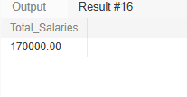
⦿ Find the minimum age among all employees.
SELECT MIN (age) as Minimum_Age FROM employees;
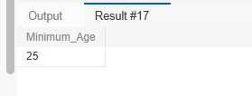
4. GROUP BY:
⦿ List the maximum salary for each location.
SELECT L. location, max (e. salary) as Max_Salary FROM employees e JOIN location L
ON e. location_id=L.location_id
GROUP BY L. location;
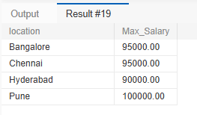
⦿ Calculate the average salary for each designation containing the word 'Analyst'.
SELECT designation, round (avg (salary),2) as Avg_Sal FROM employees
where designation LIKE '%Analyst%'
GROUP BY designation;
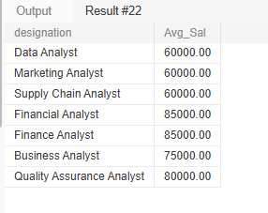
5. HAVING:
⦿ Find departments with less than 3 employees.
SELECT d. department_name, count (e. employee_id) as 'No.of Employees' FROM departments d JOIN employees e
ON e. department_id=d. department_id
GROUP by d. department_name
HAVING count (e. employee_id) <3;
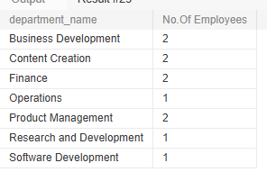
⦿ Find locations with female employees whose average age is below 30.
SELECT loc. location, avg(emp.age) as Average_Age from employees emp JOIN location loc
on emp. location_id=loc. location_id
WHERE emp.gender='F'
GROUP by loc.location
HAVING avg(emp.age) <30;
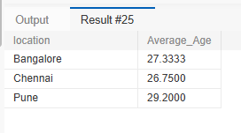
Joins:
1. Inner Join:
⦿ List employee names, their designations, and department names where employees are assigned to a department.
SELECT emp.employee_name, emp.designation, d.department_name
FROM employees emp JOIN departments d
ON emp.department_id=d.department_id;
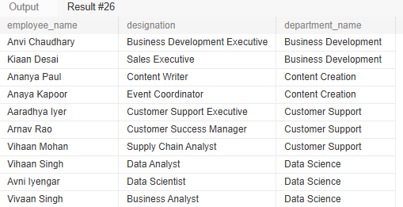
2. Left Join:
⦿ List all departments along with the total number of employees in each department, including departments with no employees.
SELECT d.department_name, count(e.employee_id) as 'No. of employees'
FROM departments d LEFT JOIN employees e
ON d.department_id=e.department_id
GROUP by d.department_name;
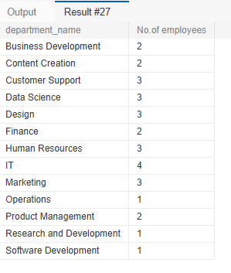

3. Right Join:
⦿ Display all locations along with the names of employees assigned to each location. If no employees are assigned to a location, display NULL for employee name.
SELECT loc.location, emp.employee_name FROM employees emp RIGHT JOIN location loc
on loc.location_id=emp.location_id;
